14th May 2018

Guerreri storms to Race 2 Glory & Björk wins Race 3 in Germany

Touring car legend Yvan Muller was the big winner at the world’s toughest race track, taking the lead of the WTCR – FIA World Touring Car Cup by adding P3 in Race 3 to his Race 1 triumph and move to the top of the title standings after a weekend of racing drama in Germany.

Argentine Esteban Guerrieri joined his compatriots, the great Juan Manuel Fangio and triple World Touring Car champion José María López, with his first Nurburgring Nordschleife victory following a thrilling drive in Race 2, with Thed Björk claiming his first WTCR success of 2018 to complete a memorable event for Muller’s YMR team.

Having won Race 1 on Thursday evening, Frenchman Muller claimed fourth place in Race 2 before completing the podium in Race 3 in his Hyundai i30 N TCR. His performance, coupled with a weekend of woe for erstwhile championship leader Gabriele Tarquini, means he takes a 19-point lead into the next event at Zandvoort, Netherlands.

In contrast, Italian Tarquini endured a difficult trip to Germany and failed to add to his score after crashing out of both Race 1 and 2, rendering him a non-starter for third counter.
Tarquini was checked over by circuit medics but given the all-clear following his Race 2 exit, the result of contact with Gordon Shedden, which earned the Scot a 30-second penalty.

Meanwhile, 2017 World Touring Car champion Björk made the most of his second top start in Race 3. The Swede withheld an impressive challenge from Belgian Frédéric Vervisch’s rapid Audi Sport Team Comtoyou’s RS 3 LMS in the final three-lap battle on Saturday afternoon to become the seventh different winner of an increasingly competitive inaugural WTCR season which boasts Japanese premium tyre manufacturer YOKOHAMA as exclusive tyre supplier. Vervisch claimed the Best Lap Trophy following a strong showing.

Earlier in the day, All-Inkl.com Münnich Motorsport’s Esteban Guerrieri also scored his first victory of 2018 in the reverse-grid Race 2, his Honda Civic Type R TCR beating pole starter Pepe Oriola to victory around the epic 25.378-kilometre circuit. Oriola, in a Team Oscaro, Campos Racing Cupra, was competing on the Nordschleife for the first time.

The FIA World Touring Car Cup resumes in The Netherlands from 19th-21st May.

Driver Standings
Yvan Muller 137pts
Gabrielle Tarquini 118pts
Thed Björk 112pts

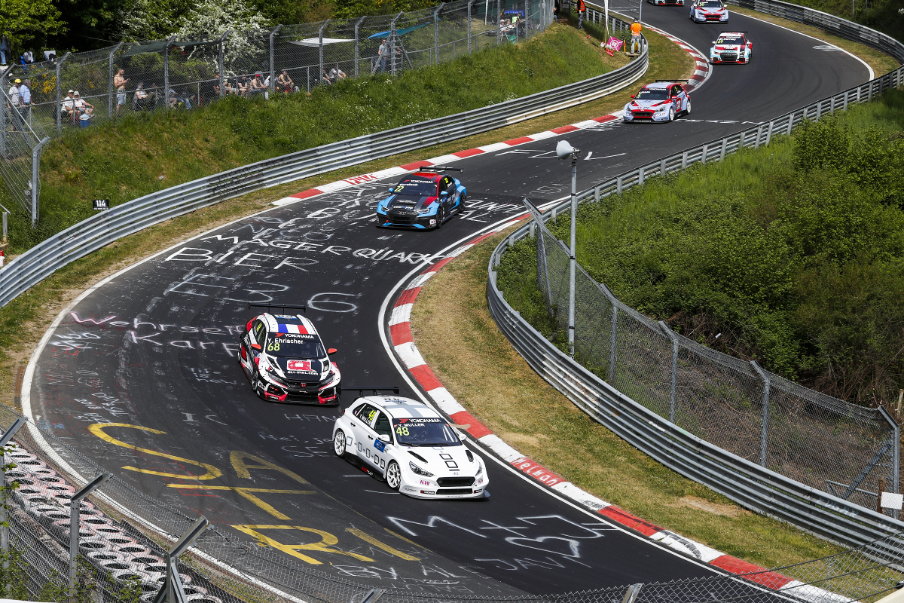
Muller leads the WTCR - Photo Clement Marin
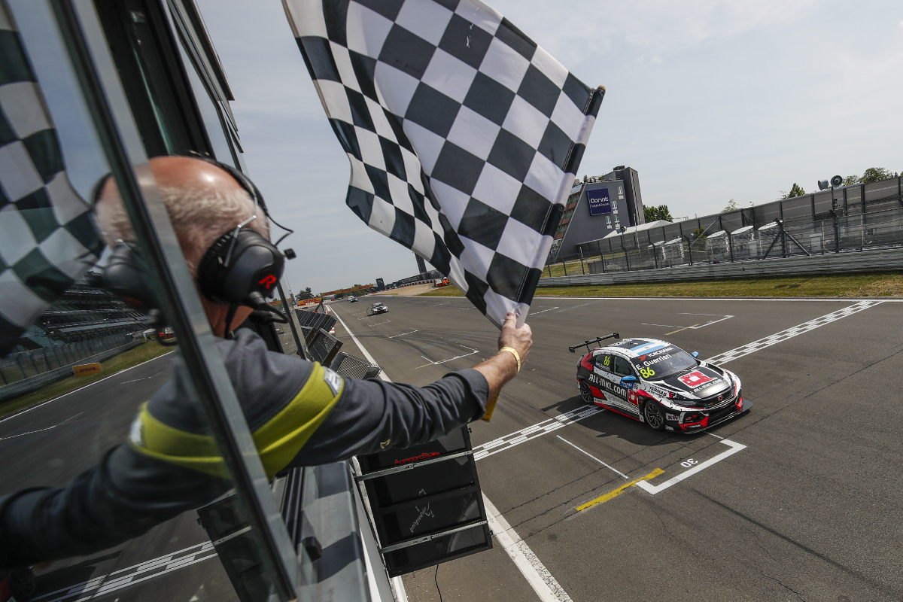
Guerreri wins Race 2 - Photo Florent Gooden

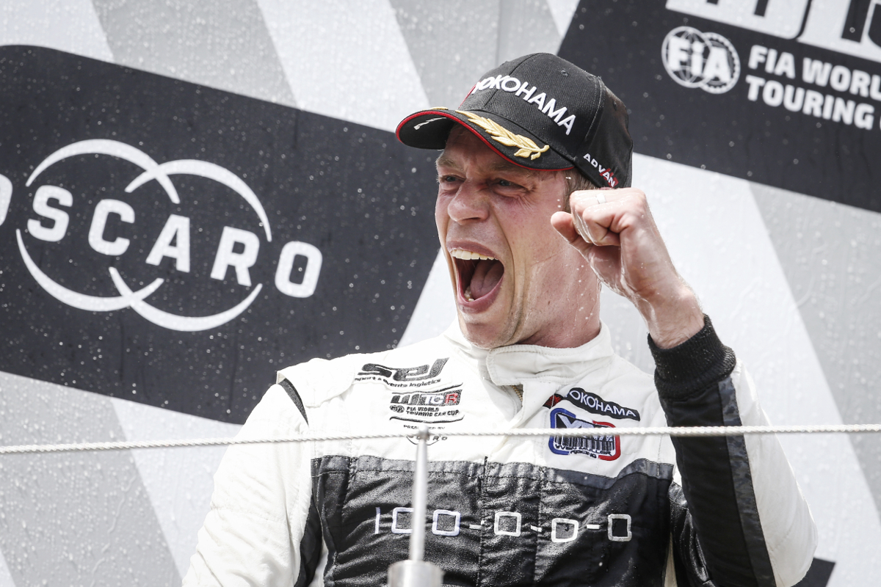
Thed Bjork celebrates race 3 win - Photo Francois Flamand

